**1.2 Variables and Arithmetic Expressions**

Consider the following program which converts Fahrenheit to Celsius:

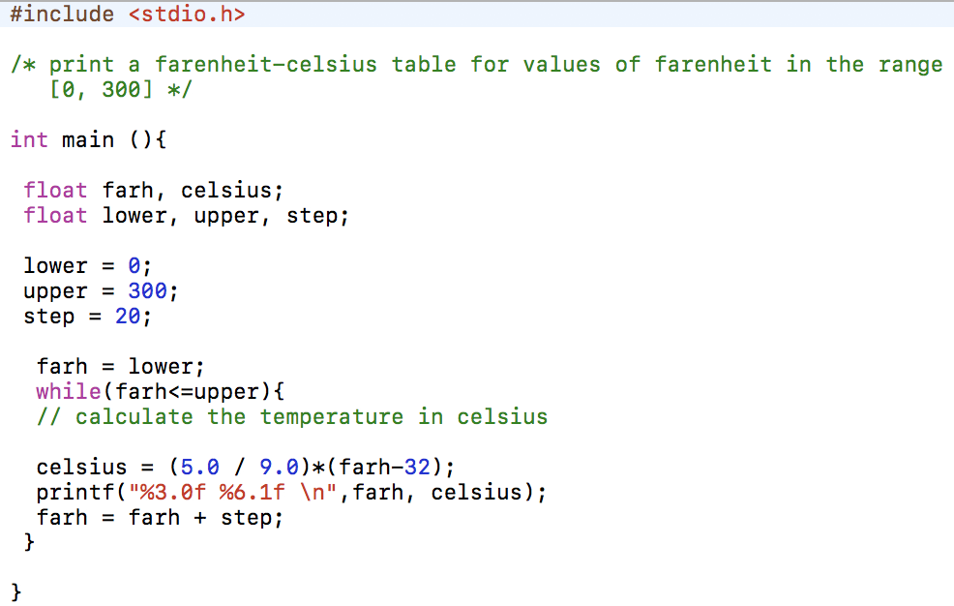

Any characters between /* and */ are considered comments and are ignored by the compiler; They can be used freely to make the program more readable.

In C, all the variables must be declared before they’re used – they’re usually declared at the beginning of the function and before any statements are executed. Formally, a declaration announces the name and properties of a variable.

The size of variables in C are machine-dependent. C data types include: int, double, float, char, short, long, arrays, structures, union, pointers, functions.

The body of a while loop can be one or more statements enclosed in braces. The code segment above includes a traditional while loop, however, a while loop can contain a single line which is indented by a tab as seen below:

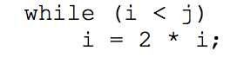

Most of the work in this program is done within the while loop. In the calculation for Celsius was initially performed as follows (pre-modification): 

The reason for this is that the program was originally written as both the farh and Celsius variables being initialized as integers. Doing the calculation in this manner avoids a property associated with integer arithmetic. The value (5/9) in terms of integer division is equal to zero. This is because integer division truncates the values – meaning the fractional part of any whole number is removed. In this case, 0 is the whole number and .56 is the fractional part. Since 5 and 9 are both whole numbers, 5/9 would be truncated and all conversions would be reported as zero.

The printf function is a general-purpose outputting function. It’s first argument the output specifier, a string which is fed into the output-formatting function, and the second and the nth arguments match up with the printf format specifiers. Each % specifies where the arguments to the function are supposed to be placed in the parameter listing. Each type and output specifier must match up for proper execution.

Printf is not part of the C language. There is no I/O defined in C itself. Printf is just a useful function located in the standard library – this library should be the implemented uniformly across all C compilers as it’s ANSI standard.

The printf conversion specification “3.0f” specifies that a floating point number is to be printed at least 3 characters wide, with 3 decimal points and zero fractional points. “%6.1f” describes a variable which is to be printed at least 6 characters wide with 1 decimal point.

The %f format specifier just says to print a variable of type float – in fact, there doesn’t need to be any additional format specifications. Printf also recognizes %o for octal, %x for hexadecimal and %c for the character.